Westpac Automation Practical Assessment  
Instructions:

Please answer following questions and reply to the email that you have received with answers when you are done.

## Summary:

You are an Automation Tester on an agile project. You have following stories in backlog. Please write automation script(s) for user stories 1 and 2 listed below.

**Website Details**

* URL to be used for this exercise: <http://www.westpac.co.nz/>
* Navigation Flow KiwiSaver > KiwiSaver Calculators > Click here to get started button under (Westpac KiwiSaver Scheme Retirement Calculator)

**Solution Requirements**

* You may use any language, tool/framework to automate the user stories
* Your solution should reflect your level of expertise
* Please upload/share your solution to an online source control repository (e.g. GitHub, CodePlex)
* Write clear instructions on how to execute the test
* Mention any prerequisites / Setup Information for the test
* Include instruction on any tools that may be required to execute the test

### Test User Story 1:

**Priority: Major**

**As a Product Owner**

I want that while using the KiwiSaver Retirement Calculator all fields in the calculator have got the information icon present

**So that**

The user is able to get a clear understanding of what needs to be entered in the field .

***Acceptance Criteria***

**Scenario 1**

Given User Clicks information icon besides Current age the message “This calculator has an age limit of 64 years old as you need to be under the age of 65 to join KiwiSaver.” is displayed below the current age field.

### Test User Story 2:

**Priority: Major**

**As a Product Owner**

I want that the KiwiSaver Retirement Calculator users are able to calculate what their KiwiSaver projected balance would be at retirement

**So that**

The users are able to plan their investments better.

**Acceptance Criteria**

* User whose Current age is 30 is Employed @ a Salary 82000 p/a, contributes to KiwiSaver @ 4% and chooses a Defensive risk profile can calculate his projected balances at retirement.
* User whose current aged 45 is Self-employed, current KiwiSaver balance is $100000, voluntary contributes $90 fortnightly and chooses Conservative risk profile with saving goals requirement of $290000 can calculate his projected balances at retirement.
* User whose current aged 55 is not employed, current KiwiSaver balance is $140000, voluntary contributes $10 annually and chooses Balanced risk profile with saving goals requirement of $200000 is able to calculate his projected balances at retirement.

### Sample Screen Shots

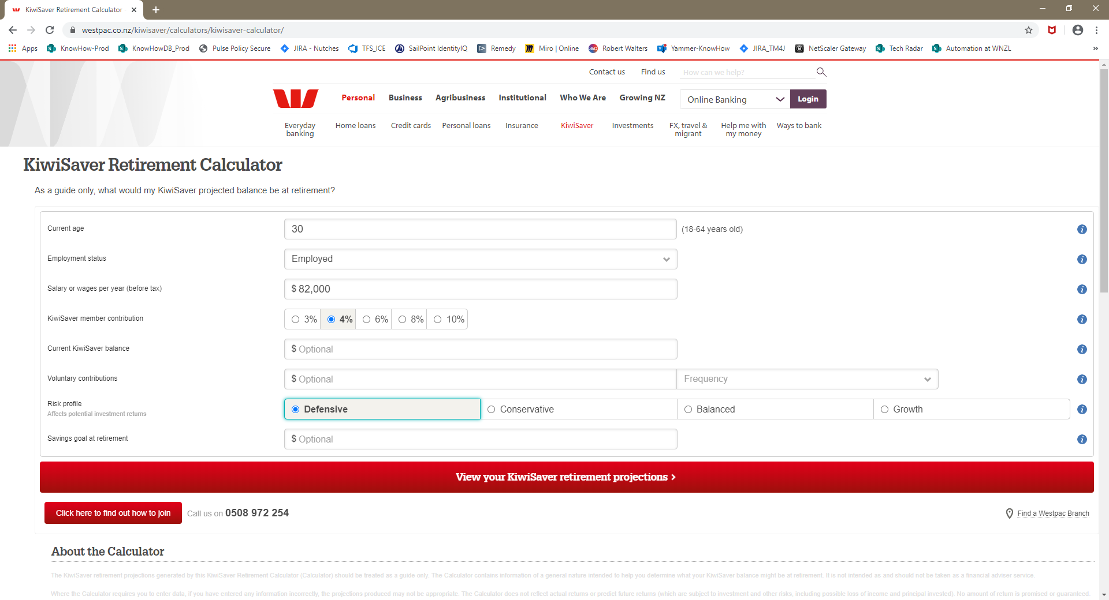

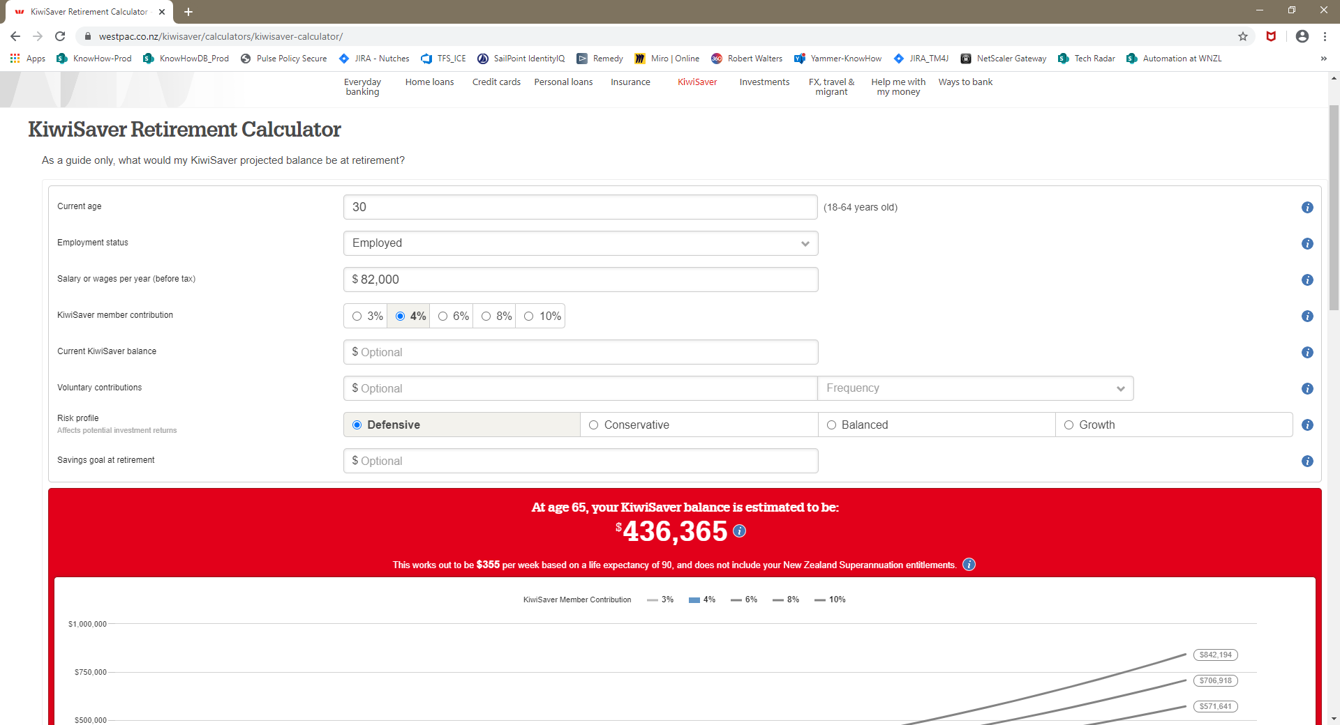

If you have any questions, please contact:

[Abhijeet_Singh@westpac.co.nz](mailto:Abhijeet_Singh@westpac.co.nz)